Space Plasma Physics (PHYS 712/812)

Homework #4

Due May 3, 2020

Figure 1 shows satellite data from the THEMIS-A spacecraft on January 17, 2013. Note that GSE coordinates are: +X is from the Earth to the sun, +Y is in the plane of Earth’s orbit in the opposite direction, and +Z is perpendicular to both in the northern direction. Use the plots, and value estimates taken from the plots, to answer the following questions:

1. Identify the regions that the spacecraft occupies during the time periods marked with A, B, and C.

A. Magnetopause

B. Magnetosheath

C. Bow Shock

2. Estimate the outward distance, in RE, of the magnetopause location in the direction of the sun from pressure balance. Does this match the location shown on the plot (using the X, Y,Z coordinates at the bottom)? If not, why not?



L­s = (**µ0= 12.57 × 10-7 H/m)*(4.0atoms / cc^3)^(-1/6) * ((3.1x10^4nT)/(1.3x10^4)^(1/3)**

**Ls = 8.34**

This does not exactly match the location shown o the plot, this can be explained due to differences in experimental data verses theoretical equations.

3. Estimate the outward distance, in RE, of the bow shock from the equations in the notes. Does this match the location shown on the plot? If not, why not?

Rbowshock / Rmagnetopause = 1+ 1.1 (Ninfinity/N)

With Ninfinity = 1

Rbowshock / Rmagnetopause = 1.0111

4. Estimate the energy input rate (in Watts) using the epsilon coupling parameter, using l=rmp.

-7h/m)*( 1609344km/hr)*()*sin4

Unable to relate to l=rmp.

5. Does the plot indicate any ongoing geomagnetic activity? Explain.

The plot shows a residual amount of AE effect lingering past the 3/18 cutoff date, along with a substantial amount of SST activity. While not as strong as the initial 3/17 plasma storm, this may be considered an ongoing geomagnetic activity.

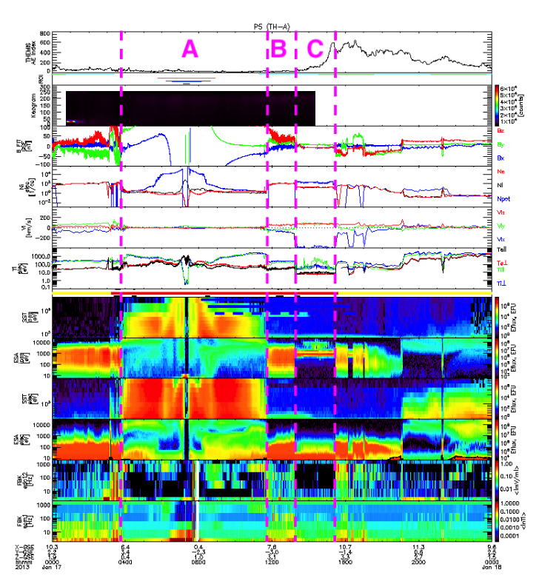

Figure 1: THEMIS-A data from January 17, 2013. The panels, from top to bottom, are AE, keogram of auroral brightness, magnetic field (B FIT), density (Ni, Ne), ion velocity (V), temperature (Ti, Te), ion energy flux (SST: high E, ESA: low E), electron energy flux, and spectrograms for electric and magnetic fields (FBK).